Gender Disparity in School Education: A Case of Punjab

Divya Budhia and Dr. Tushinder Preet Kaur

Biographical Notes

Divya Budhia Gupta is pursuing Ph.D. (Lovely Professional University), UGC-NET qualified, has done M.A. Economics (D.A.V. College, Jalandhar), and B.Sc. Economics (PCM S.D. College for Women, Jalandhar). She is working as Assistant Professor of Economics in P.G. Department of Economics of PCM S.D. College for Women, Jalandhar, Punjab (India). Her area of research is Education. She has experience of 10 years. She has presented papers in various international and national conferences/seminars. She has also got various research papers published in refereed national and international journals and has contributed chapters in edited books. She has authored one book on Business Statistics. She has also guided many post graduate students for their research projects. She is Member, Board of Studies, Guru Nanak Dev University, Amritsar and is actively involved in various activities at the institutional level.

Dr.Tushinder Preet Kaur has done Ph.D (Guru Nanak Dev University), M.Phil (Guru Nanak Dev University), M.Sc(Hons) Economics (Guru Nanak Dev University), and B.Sc (Hons) Economics (Guru Nanak Dev University). She is currently Professor at Mittal School of Business (MHRD NIRF India Rank 52; ACBSP USA, Accredited), Lovely Professional University, Phagwara, Punjab (India).In academic career spanning over 12 years, she has served at Khalsa College of Women, Amritsar and Departmental research scholar at Punjab School of Economics, GNDU, Amritsar. She has presented papers in various national and international conferences. She has to her credit various research papers published in refereed, national and international journals of repute. She has authored many chapters in referred books. She has chaired the session and acted as a Resource person for various national seminars/conferences. Currently, she is assisting Mittal School of Business as a Coordinator of Research. She has guided many students in their research work.

ABSTRACT
Education forms the base of human resource development, which in turn is quintessential for the economic development of a nation. But, disparities in educational opportunities on one basis or the other are widely prevalent in our country. Though the overall literacy rates have improved over time, but wide discrepancies are still prevalent among male and female literacy. This paper attempts to highlight gender disparity in education in the state of Punjab during 1991 and 2011. Analysis of gender gap in literacy has been done using tables and graphs. The technique of Gini coefficient has been deployed to measure the regional disparity in male and female education. Also, spatial analysis has been done using table and maps to identify leading and lagging regions and districts. The results will have useful policy implications for the government in Punjab.

Keywords: Gender inequality, regional disparity, education, literacy, Gini coefficient, spatial analysis, Majha, Malwa, Doaba, Punjab

INTRODUCTION

Education is the transfer of information from one person to the other though spoken words, gestures, audio or visual medium. It is vital for the overall well being of the people as it makes one knowledgeable, independent and capable of taking care of oneself. Not only at the individual level, but it also plays a dominant role in laying down the foundation of a society and in determining economic development of an economy. Education increases stock of skills and productive knowledge embodied in people, and educated people create new ideas. There is wide acceptance in the literature that education contributes considerably to economic growth and development of nations (DiCorrado et al., 2015; Pegkas, 2014; and Hanushek, 2013). Thus, importance of education cannot be highlighted more for developing countries like India, where dearth of skilled human resource is still a major obstacle in the path of accelerated growth of the economy. Besides, equal access to education is one of the basic human rights, which everyone should get. But, it is shown by many studies that educational gaps between various groups of people (categorised on the basis of area, gender, religion, caste, etc.) in some countries are astounding.

Even after more than 70 years of independence, India is still educationally backward. No doubt, we are moving in right direction, but this is insufficient as there are wide variations and discriminations present in the field of education. Literacy rates are also not uniform across Indian states as some states boost of high literacy rates (like Kerala, Maharashtra, etc.) others have low rates (like Bihar, Rajasthan, etc.) while some others have managed to achieve mediocre levels (like Punjab, Haryana, etc.). India can learn as much from itself as it can from other countries because there are a wide variety of performances in educational development among the Indian states. States doing better did early promotion of education and maintained educational equity, while others failed. Punjab is one such state that has failed to uphold equality in educational opportunities to its residents, and result is for all to see. Failure of education system and dearth of employment opportunities have brought the state to the situation of mass exodus of young minds to foreign lands. This is utterly disappointing and absolutely unhealthy for the society and economy of the state. Massive inequalities exist in the state with regard to education. Though there is improvement in literacy in all the districts across the state, yet there is a clear divide in male and female literacy. This gap has remained there, though somewhat reduced, throughout the period spanning two decades i.e. from 1991 to 2011. It means some extra efforts are required on the part of the government and society to provide equal opportunities and access to all, so that there is more equality in the society. Lost opportunities lead to loss of welfare and demographic dividend. Thus, there is a dire need to reduce gaps in provision of resources and opportunities.

REVIEW OF LITERATURE

Though literacy level in Punjab has increased to 75.8 percent in 2011, it slipped from 16th rank among all Indian states in 2001 to 21st rank in 2011. Thus, it is lagging in the education sector in comparison to other states. Also, there are significant disparities in literacy across the state. Lal (2019) conducted a spatial study on urban-rural differentials in literacy rates in Punjab at district level and found that districts in the northern and north-eastern regions were way ahead than the districts in southern and south-western part of the state. Also, it was observed that there existed a wide gap in literacy rates in urban and rural areas. In a similar study by Kaushik (2018), it was asserted that only four districts, namely Amritsar, Jalandhar, Ludhiana and Patiala, have good levels of literacy due to higher rate of urbanization and better accessibility of education in these areas. In an another study, Pushkarna (2017) also points out that though overall literacy rate in Punjab is rising, but the rate of increase is decreasing over the time. Also, there were vast urban-rural and male-female differentials in literacy rates in the state. Districts in the eastern part of Punjab were having more rural literacy rate than districts in the western part. Sharmila (2019) on the other hand, did a similar analysis for the state of Haryana and brought to fore the occurrence of towering male-female differentials in literacy rates. Moreover, district-wise differentials in female literacy rates were stunningly higher than the differentials in male literacy rates. It was asserted that this was due the patriarchal nature of the society and high discrimination against women in the state. Also, there were much higher differentials in rural literacy levels across the districts in the state as compared to urban literacy levels. Singh (2017) in a study comparing literacy levels in Punjab and Haryana pointed out that both the states had shown good leap in literacy rates over the decades and were comparable in terms of literacy rates in 2011. Also, both were similar in aspect of significant prevalence of spatial and male-female literacy differentials. But, it was found that male-female literacy differential index in Haryana was almost double as compared to that in Punjab.

Thus, the existing literature suggests that gender disparity in literacy in Punjab has not vanished with augmenting literacy rates and this issue needs further probing. This paper attempts to study and examine the extent of gender inequality in education in the state of Punjab.

RESEARCH METHODOLOGY

Research methodology is a well laid out plan to find a solution to the research problem. It includes all the steps that are associated with research, i.e. defining a research problem, statement of research gap and research questions, formulation of research objectives and hypothesis, describing the type of research, types and sources of research data, data collection method and instrument, scope of the study, technique for data analysis, etc. A clear-cut and strong methodology makes research incredibly smooth and reliable. There are ample techniques to carry out data analysis and there are numerous measures to know deviations in the data. Gender disparity in education has been shown with the help of table and graphs. Gini Index measures relative inequality; relative inequality is also important and needs to be measured as it fosters violent crimes because it is associated with social strains and the feeling of relative deprivation (Goda, 2016). In this paper, the Gini coefficient has been applied in context of male and female education. Also, spatial analysis has been done to identify the leading and laggard regions and districts in terms of gender disparity. Scope of study is the state of Punjab and secondary data for the years 1991, 2001 and 2011 have been taken from various Population Censuses.

Objectives
The main objectives of the study are as follows:
1. To analyse the gender differentials in literacy in Punjab
2. To examine regional disparity in male and female literacy in Punjab
3. To identify leader and laggard districts in terms of gender gap in literacy in Punjab

Hypothesis
H_{0A} : Over a period of time gender gap in literacy has not undergone any significant change
H_{0B} : There is no significant change in the regional disparity in male and female literacy in Punjab

RESULTS & INTERPRETATION

In the following section, results of the analysis have been presented in three parts. In Part (A), trends in gender disparity in literacy rates in Punjab have been discussed. In Part (B), regional inequality in male and female literacy rates in Punjab has been discussed and in Part (C), results of spatial analysis have been presented.

Part (A) Gender Disparity in Literacy in Punjab

Gender gap in literacy still exists in the state of Punjab. However, the gap in literacy has been falling during 1991 and 2011.

Figure 1: Trends in Gender Gap in Literacy Rate in Punjab (1991-2011)

Source: Economic and Statistical Organisation, Punjab, Director, Census Operation, Punjab

In above figure, it is shown that gender gap in literacy was 15.25 percent in 1991, which came down to 9.7 percent in 2011. There was however, rise in gender gap in literacy in the decade of 1981-91 as indicated by negative value of decadal fall (i.e. -13.21 percent). Afterwards, there has been a continuous fall in the gender gap, but the fall is lesser in 2001-11 than in 1991-2001. There has been fall in gender gap in literacy in all the districts of the state during 1991 to 2011, but the rate of fall has slowed down.

Figure 2: District Wise Gap in Male and Female Literacy Rate in Punjab

Source: Self computed (on the basis of Census Data for various years)

Above figure shows that gender gap in literacy is present across all the districts in the state. Though the gap has come down from the levels in 1991, yet these still exist and are quite high. Gender gap in literacy in 2011 neared the 10 percentage mark in majority of the districts in the state. The lowest gender gap in literacy is in Jalandhar, 7.6 percent, whereas gender gap in literacy is highest in Fazilka, 15.69 percent.

Part (B) Regional Inequality in Male & Female Literacy in Punjab
In this section Gini Coefficient has been calculated for total literacy, male literacy and female literacy in the state of Punjab for the years 1991, 2001 and 2011. First of all cumulative percentages of total population and literate population for all the districts in the state have been computed. Then line of equality and Lorenz curve have been plotted by taking cumulative percentage of literate population on vertical axis and cumulative percentage of total population on horizontal axis. Then area under the Lorenz curve has been calculated by the technique of integration: Gini Coefficient = 1 – 2{₀¹∫ F(X) dx} (Catalano et al., 2009). Gini value closer to zero means higher equality in the distribution whereas, Gini value closer to one implies higher inequality in the distribution.

Table 1: Gini Coefficient for Total, Female & Male Literacy in Punjab (1991-2011)
Gini Coefficient for: | 1991 | 2001 | 2011
Total Literacy | .33 | .1104 | .0684
Female Literacy | .273 | .1374 | .0904
Male Literacy | .4514 | .0886 | .0545
Source: Self Calculation

The table indicates that Gini co-efficient for literacy has been declining for all the three variables i.e. total, female and male literacy levels in Punjab during 1991 and 2011. This means that inequality is reducing among different districts of the state in terms of literacy. In 1991, inequality in male literacy levels was higher than in female literacy levels. But, in 2011, inequality in female literacy rate is higher than that in male literacy. Thus, disparities still persist in the state in terms of literacy rates, especially in case of its female population.

Figure 3: Trends in Gini Coefficient for Total, Female and Male Literacy in Punjab

It is clear from the figure that Gini coefficient had been falling both for male as well as for female literacy in Punjab during the period 1991 to 2011. Thus, the first hypothesis has been rejected and therefore, regional disparity in literacy rates in Punjab is time variant. But, the rate of fall has slowed down for both. Moreover, the second hypothesis has also been rejected as the rate of fall had been much slower in case of female literacy than in the case of male literacy, thereby leading to educational inequality still higher among female population in different districts of the state than among the male population.
Part (C): Leaders & Laggards in Gender Gap in Literacy in Punjab
In this part, spatial study of gender differential in education is done for the state of Punjab in the three census years of 1991, 2001 and 2001.

Gender Gap in Literacy Rate
Between 5 and 9.99
Between 10 to 14.99
Between 15 and 19.99
1991 2001
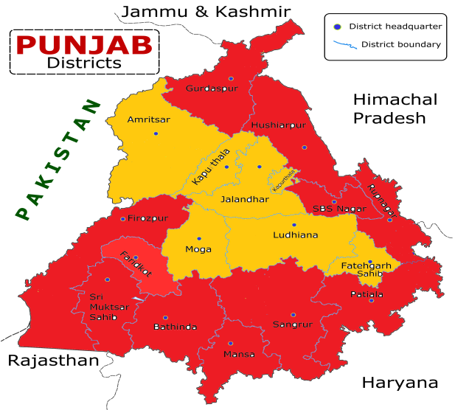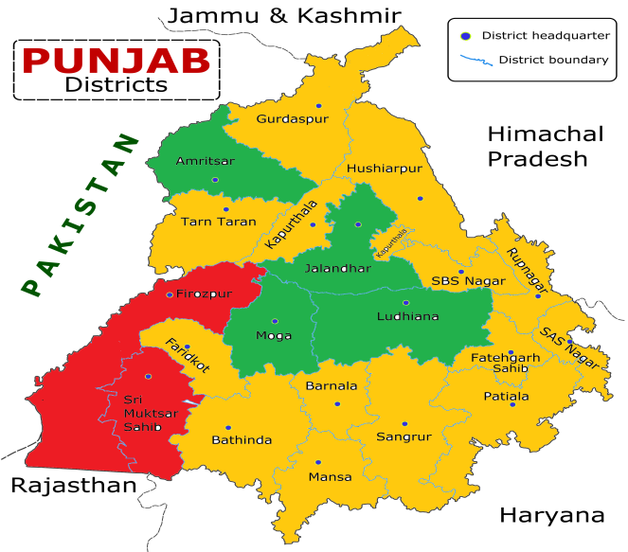
2011
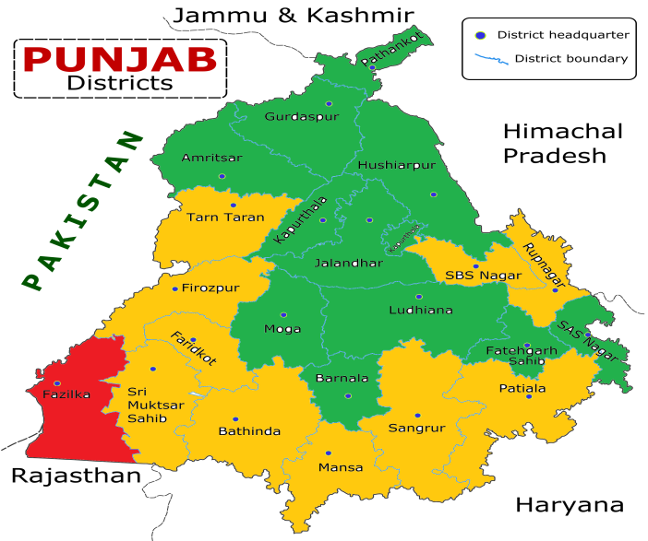

It is clear from above pictures that there has been considerable improvement in gender gap in literacy across all the districts of Punjab during the three decades from 1991 to 2011. Red zone indicating literacy gap between 15 and 19.99 per cent shrunk immensely between 1991 and 2001, and almost vanished in 2011. On the other hand, green zone indicating literacy gap between 5 and 9.99 per cent was missing in the year 1991, but had been continuously expanding afterwards, to cover almost half of the area of the state in 2011. Orange zone representing literacy gap between 10 and 14.99 per cent swelled hugely in 2001 to cover 70 per cent districts in the state. However, the orange zone got reduced in 2011 as some of the districts in it moved on to become a part of green zone.
There is general improvement in the performance of districts of the state in terms of gender gap in literacy. Many of the districts belonging to red zone showed phenomenal growth over a period of two decades and jumped to green zone s. a. Gurdaspur, Hoshiarpur, S.A.S. Nagar and Barnala. Rest of the districts in red districts in this zone moved to orange zone, except Fazilka, which was the only district to remain in red zone in 2011. The districts which belonged to orange zone in 1991, moved on to green zone in 2001, with an exception of Tarn Taran and Kapurthala. Kapurthala, however joined the green area in 2011, but Tarn Taran failed to make any improvement in this direction. It is clear that almost all the districts have succeeded in reducing the differences in male-female literacy rates, but in this sphere also the north-south divide is visible. Thus, government needs to make some extra efforts for districts in the southern part of the state so as to bring equality, and hence, peace and harmony.
Gender differentials are also not uniform across different geographical divisions of the state i.e. Majha, Malwa and Doaba. Following table makes a comparative analysis of these regions on the basis of gender gap in literacy rates in different districts of the state. Here, districts have been divided in to three categories “between 5 and 9.99”, “between 10 and 14.99” and “between 15 and 19.99”. Such analysis is done for the years 1991, 2001 and 2011; thus, gauging the performance straddling three decades.

Table 2: Region-wise Classification of Districts on the Basis of Gender Gap in Literacy Rate
 | Majha | Malwa | Doaba
1991 (Avg.= 15.25)
Between 5 and 9.99 | - | - | -
Between 10 to 14.99 | Amritsar | Ludhiana, Moga, Fatehgarh Sahib | Jalandhar, Kapurthala
Between 15 and 19.99 | Gurdaspur | Ropar, Ferozepur, Faridkot, Muktsar, Bathinda, Mansa, Sangrur, Patiala | SBS Nagar (Nawanshahr), Hoshiarpur
2001 (Avg.= 11.8)
Between 5 and 9.99 | Amritsar | Ludhiana, Moga | Jalandhar
Between 10 to 14.99 | Gurdaspur, Tarn Taran | SAS Nagar, Barnala, Fatehgarh Sahib, Ropar, Faridkot, Bathinda, Mansa, Sangrur, Patiala | SBS Nagar (Nawanshahr), Kapurthala, Hoshiarpur
Between 15 and 19.99 | - | Ferozepur, Muktsar | -
2011 (Avg.= 9.7)
Between 5 and 9.99 | Gurdaspur, Amritsar, Pathankot | SAS Nagar, Moga, Ludhiana, Barnala, Fatehgarh Sahib | Kapurthala, Jalandhar, Hoshiarpur
Between 10 to 14.99 | Tarn Taran | Ropar, Ferozepur, Faridkot, Muktsar, Bathinda, Mansa, Sangrur, Patiala | SBS Nagar
Between 15 and 19.99 | - | Fazilka | -
Source: Self Calculations

Table 4.2 suggests that there exists high regional inequality in Punjab in terms of gender gap in literacy. Malwa region has a high gender gap in literacy as compared to Majha and Doaba regions. Districts of Gurdaspur, Amritsar, Pathankot, SAS Nagar, Moga, Ludhiana, Barnala, Fatehgarh Sahib, Kapurthala, Jalandhar, Hoshiarpur, with gender gap in the lowest range (5-9.99), are the leaders whereas district Fazilka, with gender gap in the highest range (15-19.99) and districts Tran Taran, Ropar, Ferozepur, Faridkot, Muktsar, Bathinda, Mansa, Sangrur, Patiala and SBS Nagar lying in high range (10-14.99) are laggards.

SUGGESTIONS & CONCLUSION
The above analysis indicates that though the literacy levels have increased in Punjab during 1991 to 2011, but the discriminations still subsist many are still deprived of their basic right of education. This is not a healthy state of affairs as such inequities brew tensions and clashes in the society and harm its harmony, which is sin-qua-non for economic advancement. Therefore, some of the suggestions in this regard have been mentioned below:
- The goal of universal education should be pursued ever aggressively. The gap between male and female literacy needs to be removed and all efforts should be directed towards this end. More schemes, like Beti Bachao Beti Padhao and Mai Bhago, should be initiated to specifically improve the levels of female education.
- To address the problem of regional disparity in male and female literacy, under-performing districts should be identified and excessive stress be laid on improvement of literacy rates in laggard areas and districts in the state.
- Even when the school education has been made free, the poor send their children to work rather than schools so as to earn money. Extra financial assistance can be given to such weaker sections of the society.
- But, most importantly an attitudinal change is urgently and seriously called for to transform the existing state of affairs. Only a change in outlook towards education can bring the desired improvement in literacy rates in general and female literacy rates in particular.

Above discussion makes it clear that gender gap in literacy rates in Punjab have been falling during the period 1991 to 2011. Thus, our first hypothesis “Over a period of time gender gap in literacy has not undergone any significant change” has been rejected. Also, regional disparity in male and female literacy rates has been falling during the study period, as indicated by the decline in the value of the Gini coefficient. So, our second hypothesis “There is no significant change in the regional disparity in male and female literacy in Punjab” has also been rejected. But, it can be concluded that regional inequalities in context of literacy still persist in Punjab, and more so in case of female population. Similar results were propounded by Lal (2019), Kaushik (2018) and Pushkarna (2017) in studies related to rural-urban divide in Punjab in terms of literacy rate. Further, the fall in regional inequality in literacy is in consonance with the studies at national level (e.g., Bhakta, 2015), which asserted that though regional gaps still existed in India, those were reducing with time.

References
Bhakta, R. (2015). Educational Attainment of Young Adults in India: Measures, Trends & Determinants. WP-2015-034 (Indira Gandhi Institute of Development Research). Retrieved from: www.igidr.ac.in/pdf/publication/WP-2015-034.pdf
Bordoloi, N., Sharma, A., Nautiyal, H., & Goel, V. (2018). An intense review on the latest advancements of Earth Air Heat Exchangers. Renewable and Sustainable Energy Reviews, 89, 261-280.
Catalano, M. T., Leise, T. L., & Pfaff, T. J. (2009). Measuring Resource Inequality: The Gini Coefﬁcient. Numeracy, 2(2). Retrieved from: https://www.researchgate.net/publication
/45183289
Datta, S., Singh, J., Singh, S., & Singh, J. (2016). Earthworms, pesticides and sustainable agriculture: a review. Environmental Science and Pollution Research, 23(9), 8227-8243.
DiCorrado, E., Kelly, K., & Wright, M. (2015). The Relationship between Mathematical Performance and GDP per Capita. Retrieved from https://smartech.gatech.edu/bitstream/handle/1853/54222/the_relationship_between_mathematical_performance_and_gdp_per_capita_1.bk-2.pdf
Goda, T. (2016). Global trends in relative and absolute income inequality.Ecos de Economía, 20(42). Doi: 10.17230/ecos.2015.42.3
Goga, G., Chauhan, B. S., Mahla, S. K., & Cho, H. M. (2019). Performance and emission characteristics of diesel engine fueled with rice bran biodiesel and n-butanol. Energy Reports, 5, 78-83.
Hanushek, E. A. (2013). Economic Growth in Developing Countries: The Role of Human Capital. Retrieved from https://hanushek.stanford.edu/sites/default/files/publications
/Education%20and%20Economic%20Growth.pdf
Kapoor, B., Singh, S. K., Gulati, M., Gupta, R., & Vaidya, Y. (2014). Application of liposomes in treatment of rheumatoid arthritis: quo vadis. The scientific world Journal, 2014.
Kaushik, M. (2018). Urban-Rural Differential in Literacy Rate: A Case Study of Punjab. Journal of Advances and Scholarly Researches in Allied Education, 15 (11), 526-530.
Lal, M. (2019). Spatial Pattern of Literacy in Punjab: Rural – Urban Differential. Journal of Advances and Scholarly Researches in Allied Education, 16 (1), 679-682.
Pegkas, P. (2014). The Link between Educational Levels and Economic Growth: A Neoclassical Approach for the Case of Greece. International Journal of Applied Economics, 11(2), 38-54. Retrieved from https://www2.southeastern.edu/orgs/ijae/index_files/IJAE%20SEPT%202014%20PEGKAS%207-30-2014%20RV.pdf
Pushkarna, M. (2017). Literacy Patterns in Punjab: Rural- Urban Differentials. IOSR Journal Of Humanities And Social Science, 22(7), 32-39.
Sharmila. (2019). An analysis of trends in literacy, differential literacy and spatial pattern of literacy rate in Haryana state, India. International Journal of Multidisciplinary Education and Research, 4 (3), 12-16.
Singh, V. (2017). Rural Literacy in Punjab and Haryana: A Comparative Current Scenario and Changes during the Last Four Decades. International Journal of Science and Research, 6 (6), 717-724.
Vij, S., & Bedi, H. S. (2016). Are subjective business performance measures justified?. International Journal of Productivity and Performance Management.
Wheeler, K. C., Jena, M. K., Pradhan, B. S., Nayak, N., Das, S., Hsu, C. D., ... & Nayak, N. R. (2018). VEGF may contribute to macrophage recruitment and M2 polarization in the decidua. PLoS One, 13(1), e0191040.
https://censusindia.gov.in/

Research Scholar in Economics, Mittal School of Business, Lovely Professional University, Phagwara, Punjab (India) – 144411. Email: div8@ymail.com
Professor in Economics, Mittal School of Business, Lovely Professional University, Phagwara, Punjab (India) - 144411. Email: tushinder.16446@lpu.co.in

