Evaluating The Academic Trends On Design Thinking Research: A Bibliometric Analysis From 2000 to 2021

Norliyana Md. Aris¹*, Nor Hasniza Ibrahim², Noor Dayana Abd Halim³, Sariah Ali⁴ , Nurul Hanani Rusli⁵,Maizatul Nabila Mohd Suratin⁶, Firdaus Che Hassan^{7,8}

¹²³⁴⁵⁶Faculty of Social Science and Humanities, Universiti Teknologi Malaysia 81310 Skudai, Johor Malaysia

⁷Functional Composite Structure (FCS) Focus Group, Department of Materials and Design Engineering, Faculty of Mechanical and Manufacturing Engineering

Universiti Tun Hussein Onn Malaysia 86400 Parit Raja, Batu Pahat, Johor, Malaysia

⁸ Creative Research and Innovation for Technology (CREATE) Focus Group, Department of Production and Operation Management, Faculty of Technology Management and Business

Universiti Tun Hussein Onn Malaysia 86400 Parit Raja, Batu Pahat, Johor, Malaysia

*Corresponding author E-mail: norliyana@graduate.utm.my

Abstract
"Design Thinking" opens up new avenues for boosting current educational, creative thinking instructional, and innovation research paradigms. Design thinking approaches are widely being explored in various fields to meet the inspiration of the global era. It is now recognized as the learning experience through repeating activities in a problem-solving learning environment. With the growth of design thinking, much research has been conducted. The focus of this research is to look at the current state of design thinking research and make future research directions. This study also aims to provide up-to-date maps illustrating and organizing Scopus data sets relevant to design thinking research between 2000 and 2021. The study retrieved 1875 documents for further analysis using various tools. Microsoft Excel, Harzing Perish, and VOSviewer were used to complete the bibliometric review using standard bibliometric indicators. Visualization through maps based on-network data of scientific publications displaying relationships among researchers, countries, and scientific journals. The co-occurrence of phrases related to design thinking research was analyzed through author keywords. Based on what we have discovered,design thinking research is gaining popularity among scholars. The United States, followed by Germany, was the most significant contributor to design thinking research. Most articles connected to design thinking research have been published in computer science and social science. The top author keywords in terms of co-occurrence were "Design Thinking" "Innovation" "Design" and "Creativity" are all keywords used to express design thinking. The top-cited article from the Journal Of Engineering Education is titled "Engineering design thinking, teaching, and learning". Our findings will provide a clear grasp of design thinking research bodies' evolution trends. These current work analyses are valuable and essential resources for scholars and practitioners in design thinking academic researchers.

Keywords: Design thinking, Bibliometric analysis, Trend, VOSviewer; Harzing’s Publishor Perish

- INTRODUCTION
Design thinking may appear to be a new concept on this side of the century in the academic world. However, designers' work and practiceattributes have been discussed within design studiesfor at least 20 years(Buchstab, 2005; Johansson-SkÃ¶ldberg et al., 2013; Meinel & Leifer, 2012). In today's rapidly changing technology and globally competitive environment, success calls for developing and using a unique set of competencies. Design thinking is one of these qualities(Guaman-Quintanilla et al., 2022; Henriksen et al., 2017). In 1954, William F.'s Ballhausin study was the first to adopt design thinking. His research focused on clear design thinking with aircraft growth in the technical field. The concept of design thinking did not gain momentum in the academic community until it was implemented in the architectural industry in 1994 and 1995.

However, in the last 10 years, design thinking as an approach for teaching has shown increased interest among researchers(OCDE, 2018; Beligatamulla et al., 2019; Henriksen et al., 2017; Souza et al., 2020). Leaders worldwide also believe that innovation is the source of uniqueness and competitive advantage. This is consistent with the finding by T Brown (2008), which showed that design thinking has more managerial principles and best practices to explore, has a great more to contribute to the world in the coming days. Recent evidence suggests that design thinking is seen as a collection of creative skills for understanding and resolving ambiguous, complex problems and a method for integrating people as the center of the design process(Scott et al., 2021; Soledad Ramírez-Montoya et al., 2022; Wallis, 2019). Design thinking can encourage students to generate new ideas through a hands-on approach(Tim Brown, 2019; Menezes, 2019; Viswanathan & Linsey, 2012). This exploration and engagement in the actual world with Menezeshonest feedback are crucial to connect with reflection activities.

Experiences are essential in the design thinking process because they can lead to innovative solutions.According to previous study findings, the use of design thinking in more expansive frontier learning in digital practice is outlined(Aldalalah, 2022; Androutsos & Brinia, 2019; Lyche et al., 2018). Alternatively, the growing interest in integrating design thinking into STEM(Science, Technology, Engineering, and Math) education greatly impacted the classroom's physical environment(Balakrishnan et al., 2021; Benita et al., 2021; Chiu et al., 2021).The type of related teaching approach is problem-based learning and project-based learning(Parmar, 2015; Taajamaa et al., 2014; Yen et al., 2021). Some STEM teacher professional development programs emphasize developing teacher beliefs as they do develop material or technological competency. Many recent studies in the field of design thinking suggest that it can help teachers improve their ability to utilize innovation and creativity in the classroom has been strengthened to achieve education 4.0 goals(Loyola et al., 2020;B Gleason & Cherrez, 2021). As highlighted by the Pruneau et al. (2021), design thinking is also considered an innovative problem-solving method. Design Thinking seems to have the potential to transform children's creativity, problem-solving skills, and collaborative work in the classroom(Aguado et al., 2014; Chen et al., 2019; Pellegrini, 2020).

It has been demonstrated clearly that design thinking is a collaborative technique capable of generating new ideas. Professionals and communities focus on new solutions using interdisciplinary design thinking. In this context, design thinking has extended beyond computer science discipline (O’Callaghan & Connolly, 2020; Qian et al., 2019), social science(Fisher et al., 2018; Goi & Tan, 2021; Reinecke, 2016), engineering (Harun et al., 2019; Palacin-Silva et al., 2017), Business, Management, and Accounting(Bharathi & Pande, 2019; Tim Brown, 2019; He & Ortiz, 2021), health profession (Boillat et al., 2020; BostrÃ¶m et al., 2021; Lorusso et al., 2021) art and humanities (Liu, 2020; X. Wang & Zhang, 2020), and journalism and writing(Kaivo-Oja, 2014; Purdy, 2014).

Previous bibliometric analysis was conducted on design thinking concerning entrepreneurial orientation (Johann et al., 2020), while a more current bibliometric study used a combined strategy of SLR, bibliometric analysis, and content analysis (Bhandari, 2022). The author emphasizes the diversity of design thinking research themes and sub-themes. However, past researchers suggest conducting any further research direction with appropriate research objectives for exploring further research on design thinking. Therefore, this article will summarize the current state of design thinking research and analyze the field's growth using Scopus data sets related to design thinking research from 2000 to 2021. In addition, this paper aims to provide the previous study’s findings on design thinking and provide an up-to-date visual map of the design thinking research's global development.The following is an overview of the paper's layout. First, we present an analysis of relevant literature on bibliometric analysis and previous research on design thinking-related publications. Second, we go over the methods used in this research. The results obtained from the documents gathered in the Scopus database are reported in the analysis and findings section. The overview, limitations, and recommendations for future research are discussed in the conclusion part.

- METHODS
Bibliometric data analysis provides a way to understand the intensity of research currents on a topic and the various areas of research explored by researchers. Bibliometric analysis is gaining popularity as one of the methods used to reveal trends and patterns of study (Ahmi et al., 2020). The study's design can be observed by classifying publications by year, author, affiliation, or country. The journal can also be measured based on its impact and performance using matrices such as citation number, citation per year, h index, and g index. The increasing number of studies that have been conducted using bibliometric analysis is due to the handiness of data that can be downloaded from academic databases (such as Scopus, Web of Science, and dimensions) and the availability of tools (such as VOSviewer, CitNetExplorer, and CiteSpace (Zakaria, Ahmi, Ahmad, Othman, et al., 2021).

This study used a bibliometric data analysis method to create a network map of research literature on design thinking. Bibliometric analysis was performed using the Scopus database on9 March 2022. Scopus database was chosen as the data source of this research because it contains more publications on thinking calculation and its extensive coverage in educational and social science publications (Mongeon & Paul-Hus, 2016). The search term “design thinking”in the article’s title is used to find articles published in any language related to research on design thinking. We focus on the article’s title because it is the first element that the reader will notice (Annesley, 2010). It represents relevant topics important to the research area and the study’s objectives. We refined the search to the year of publication from 2000 to 2021 to identify the latest trends in design thinking research. This article helps to provide meaningful insights into the direction of previous publications on this research topic. This study has implemented the PRISMA guidelines (Zakaria, Ahmi, Ahmad, & Othman, 2021), and a detailed flow chart for our search strategy is shown in Figure 1. All documents are subject to bibliometric analysis. We used (i) Microsoft Excel 2016 to calculate the frequency and percentage of material published and to generate relevant charts and graphs; (ii) VOSviewer (version 1.6.15) to create and visualize bibliometric networks, analyze and describe abstract keywords and authors, as well as relationships and collaborations between authors, countries, and publications in data sets; and (iii) Harzing’s Publish and Perish software to calculate citation metrics.

The study addressed five specific research questions.
RQ1. What are the publication growth and trends in design thinking?
RQ2. What are the most prolific and collaborating authors and countries of design thinking?
RQ3. What are the most collaboratingcountries’ research on design thinking?
RQ4. What are the most cited and co-citedjournals on design thinking research?
RQ5.What are the most used authors’ keywords and subject areas indesign thinking research?

- RESULTS AND DISCUSSIONS
Description of the recovered literature
A total of 1875 documents were identified from the Scopus database based on document type and source type. Table 1 summarizes the type of published documents. Ten documents have been published related to design thinking consisting of journal articles, review articles, book chapters, letters, reviews, notes, editorials, brief reviews, books, and conference reviews.Journals accounted for the most (47.73%) of the total documents published, followed by conference proceedings (33.12%), book series (11.04%), books (7.25%), while trade journals only accounted for less than 1%of the total publications ( 0.85%).
The majority of papers retrieved were published in English (95.97%), followed by Spanish (1.01%), Portuguese (0.85%), Chinese (0.80%), and German (0.53%). There are ten other languages found to be published with a total percentage below 0.1%, including French, Italian, Japanese, Croatian, Korean, and Malaysian.

Database: Scopus
Search Field:Design Thinking
Time Frame:2020 - 2021
Language:All
TITLE("Design Thinking”)
Keywords & Search String
n = 1937
Record Identified & Screened
Design Thinking
Screening
Included
Topic, Scope &Eligability
Topic
Scope & Coverage
Record Included for Bibliometric Analysis
n = 0

45\\\++\\+++
=
D’;v[=lgp=789=7n=47
Record Removed
n = 1875
9 March 2022
Date Extracted

Figure 1.Flow diagram of the search strategy(Zakaria, Ahmi, Ahmad, & Othman, 2021).

Table 1. Types of retrieved documents (2000 – 2021).
Document Type | Total Publications (TP) | Percentage (%)
Conference Paper | 822 | 43.84%
Article | 755 | 40.27%
Book Chapter | 144 | 7.68%
Review | 51 | 2.72%
Note | 33 | 1.76%
Editorial | 25 | 1.33%
Book | 20 | 1.07%
Letter | 8 | 0.43%
Short Survey | 8 | 0.43%
Conference Review  Undefined | 2  7 | 0.11%  0.37%
Total | 1875 | 100.00

Publication Growth and Trends in Design Thinking Literature
A search on the Scopus database found 1875 scientific articles published from 2000 to 2021. Patterns over time were assessed by examining documents based on the year of publication. Trends in publications and citations are essential indicators in determining developments in a discipline, field, or topic(Qi et al., 2021). There was an increase in the number of publications of documents during the study period. Figure 2represents the publication trend of design thinking papers between 2000 and 2021, the distribution of the number of publications, and the cumulative percentage by year. The data was retrieved from the Scopus database using the keyword “design thinking”.

From 2000 to 2006, only 27 articles were published, and these publications were cited 3004 times. An increasing trend has been observed from 2007 to 2014, with 315 papers have been published. Between (2015–2021), the publication grew to 1533 articles, whereas the citations were 8553 times. The journal has shown impressive growth in terms of publication and total citation. This has established an impressive growth trend in total publications and citations in design thinking research.

The highest productivity was observed in 2021, with 302 documents. The annual citation matrix for documents retrieved is shown in Table 2. The number of citations per publication is the highest for documents published in 2005 (121.24 citations per publication), while the lowest is for documents published in 2002 (1.20 citations per publication).

315 Articles
27 Articles
1533 Articles

The future research direction of the topic. The field of design thinking is gaining attention.

Figure 2. The rapid growth of design thinking publications, 2000 – 2021 (n = 1875).
The future research direction of the topic. The field of design thinking is gaining attention.

Table 2.An annual number of publications and citation matrix.
Year | TP | NCP | TC | C/P | C/CP | h | g
2000 | 2 | 2 | 97 | 48.50 | 48.50 | 2 | 2
2001 | 3 | 2 | 124 | 41.33 | 62.00 | 1 | 3
2002 | 3 | 3 | 24 | 8.00 | 8.00 | 2 | 3
2003 | 3 | 2 | 78 | 26.00 | 39.00 | 2 | 3
2004 | 3 | 3 | 144 | 48.00 | 48.00 | 3 | 3
2005 | 4 | 2 | 2061 | 515.25 | 1030.50 | 2 | 4
2006 | 9 | 5 | 476 | 52.89 | 95.20 | 3 | 9
2007 | 5 | 2 | 343 | 68.60 | 171.50 | 1 | 5
2008 | 12 | 9 | 2018 | 168.17 | 224.22 | 5 | 12
2009 | 23 | 13 | 152 | 6.61 | 11.69 | 5 | 12
2010 | 27 | 18 | 472 | 17.48 | 26.22 | 9 | 21
2011 | 48 | 34 | 1316 | 27.42 | 38.71 | 14 | 36
2012 | 62 | 50 | 1408 | 22.71 | 28.16 | 16 | 37
2013 | 54 | 48 | 1114 | 20.63 | 23.21 | 16 | 32
2014 | 84 | 64 | 1004 | 11.95 | 15.69 | 17 | 30
2015 | 98 | 88 | 1816 | 18.53 | 20.64 | 22 | 40
2016 | 177 | 130 | 2009 | 11.35 | 15.45 | 20 | 41
2017 | 174 | 130 | 1200 | 6.90 | 9.23 | 17 | 27
2018 | 227 | 161 | 1348 | 5.94 | 8.37 | 17 | 29
2019 | 258 | 172 | 1050 | 4.07 | 6.10 | 15 | 23
2020 | 297 | 169 | 860 | 2.90 | 5.09 | 14 | 20
2021 | 302 | 100 | 270 | 0.89 | 2.70 | 7 | 11
Notes: TP=total number of publications; NCP=number of cited publications; TC=total citations; C/P=average citations per publication; C/CP=average citations per cited publication; h=h-index; and g=g-index.

The Most Prolificand Co-authorship Authors Network
A total of 1875 articles were published within the scope of the design thinking study from 2000 to 2021 from 85 countries worldwide. The average number of authors per article was 2.79, indicating a trend toward the contributions of multiple authors to this research domain. Authors from many countries have published publications on design thinking. Table 3 lists the 16 most productive authors over the research period. The most productive author with the highest number of publications was Meinel, C. (25 publications; 351 citations), while Leifer, L. (16 publications; 146 citations) ranked second and Uebernickel, F. (13 publications; 184 citations) in third place of 16 most prolific authors in the study of design thinking. Nevertheless, Liedtka, J., even with 9 publications, has made an impact in design thinking research because it has the highest number of total citations which is 490 citations. Researchers Liedka, J and Leifer, L were from the United States, while the first and third highest number of publication authors were from Germany.

Table 3.Most prolific authors for design thinking between 2000-2021.
Author’s Name | Affiliation | Country | Total number of publications | Total Link Strength | Total  Citation
Meinel, C. | Hasso-Plattner-Institut für Software | Germany | 25 | 50 | 351
Leifer, L. | Stanford University | United States | 16 | 39 | 146
Uebernickel, F. | Hasso-Plattner-Institut für Software | Germany | 13 | 34 | 184
Conte, T. | Universidade Federal do Amazonas | Brazil | 10 | 22 | 43
Dobrigkeit, F. | Hasso-Plattner-Institut für Software | Germany | 9 | 13 | 30
Goldman, S. | Stanford Graduate School of Education | United States | 9 | 16 | 184
Liedtka, J. | Darden School of Business | United States | 9 | 8 | 490
Mentzer, N. | Purdue Polytechnic Institute | United States | 9 | 4 | 95
Royalty, A. | Stanford University | United States | 8 | 22 | 236
Brenner, W. | University of St. Gallen | Switzerland | 7 | 14 | 142
Canedo, E.D. | Universidade de Brasília | Brazil | 7 | 1 | 25
Cormican, K. | National University of Ireland | Ireland | 7 | 10 | 7
Hehn, J. | Berner Fachhochschule | Switzerland | 7 | 9 | 54
Liu, J. | Beihang University | China | 7 | 8 | 68
Suzianti, A. | Universitas Indonesia | Indonesia | 7 | 6 | 0
Wrigley, C. | The University of Queensland | Australia | 7 | 8 | 148

The network of co-authors of publications on design thinking from 2000 to 2021 produced 4250 authors. We identified 371 authors with a full counting method, minimum productivity of 2 documents, and a minimum total citation of 5 was visualized using the VOSviewer technique and are presented in Figure 3. However, only 113 authors were visually mapped in Figure 3 because several authors were not connected. Closed circles indicated active authors of close research collaboration.The lines between authors represent their collaborative links, while 12 different colors represent groups of authors’ collaborations. We can see how the total link strength attribute can give an idea of the total strength of an author with other researchers. Although all 16 of the top authors listed in Table 3 belong to different groups, the close and strong relationship suggests a relatively strong research link related to design thinking. For example, Meinel, C. Cluster 1 (red: 50 total link strength), Leifer, L. Cluster 5 (purple: 39 total link strength), and Uebernickel, F. in Cluster 8 (cyan: 34 total link strength) were strongly linked together, as shown in figure.

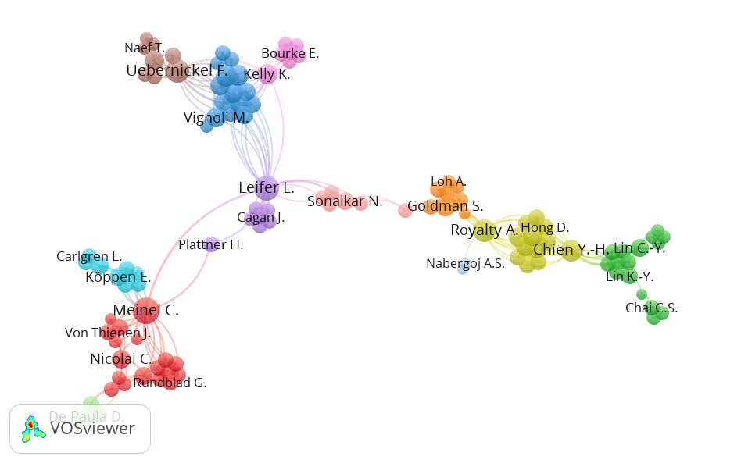
Figure 3. Network visualization map of the co-authorshippublishing on design thinking from 2000 to 2021.

Co-Authorship Countries Networkand Geographical Distribution of Publications
The national network of co-authors publishing design thoughts from 2000 to 2021 produced 135 countries. This indicates that many researchers worldwide have conducted literature reviews on design thinking. A visualization of cooperation between countries with minimum productivity of 1 document is shown in Figure 4. With a minimum of 5 citations, 55 countries are connected and grouped into 11 different clusters with colors according to clusters. Shown the top 20 countries contributing to publications are listed in Table 4. The United States ranked first in total link strength as well as total 531 numbers of documents (28.37%)and 9743 total citations, followed by Germany with 140 (7.52%) and Australia with 115 (6.13%) documents.

From the table shown, it can be seen that although some countries offer a high ranking in the number of publications, such as China (108 total publications) and Brazil (89 total publications), these countries do not rank highest in the national co-author network map. Although the research activity is within the scope of the study, it is not followed by high cooperation with other countries.

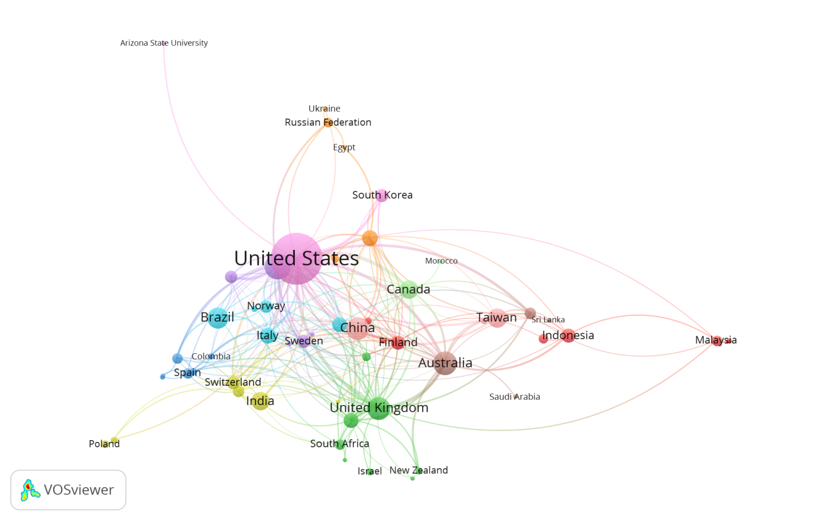

Figure 4. Network visualization map of countries publishing on design thinking from 2000 to 2021.

Table 4. The top20 countries contributed to the publicationofdesign thinking research.
Rank |  | Country |  | Total Publication | Total Link Strength |  | Total  Citation |  | Link |  | Cluster
1 | United States |  | 531 |  |  | 111 |  | 9743 |  | 33 |  | 9
2 | Germany |  | 140 |  |  | 49 |  | 877 |  | 20 |  | 5
3 | Australia |  | 115 |  |  | 44 |  | 1929 |  | 26 |  | 8
4 | China |  | 108 |  |  | 22 |  | 305 |  | 13 |  | 10
5 | United Kingdom |  | 105 |  |  | 49 |  | 1672 |  | 25 |  | 2
6 | Brazil |  | 89 |  |  | 12 |  | 326 |  | 8 |  | 6
7 | Taiwan |  | 74 |  |  | 18 |  | 500 |  | 8 |  | 10
8 | India |  | 72 |  |  | 10 |  | 178 |  | 9 |  | 4
9 | Canada |  | 67 |  |  | 29 |  | 1117 |  | 20 |  | 11
10 | Italy |  | 49 |  |  | 20 |  | 354 |  | 21 |  | 6
11 | Japan |  | 49 |  |  | 17 |  | 198 |  | 20 |  | 7
12 | Netherlands |  | 47 |  |  | 24 |  | 1190 |  | 21 |  | 2
13 | Denmark |  | 44 |  |  | 12 |  | 402 |  | 11 |  | 6
14 | Finland |  | 40 |  |  | 22 |  | 244 |  | 20 |  | 1
15 | Indonesia |  | 40 |  |  | 8 |  | 33 |  | 7 |  | 1
16 | Switzerland |  | 35 |  |  | 13 |  | 302 |  | 14 |  | 4
17 | Sweden |  | 34 |  |  | 14 |  | 870 |  | 14 |  | 5
18 | South Korea |  | 34 |  |  | 9 |  | 90 |  | 5 |  | 9
19 | Ireland |  | 30 |  |  | 11 |  | 257 |  | 10 |  | 5
20 | Norway |  | 30 |  |  | 8 |  | 188 |  | 8 |  | 6

Citation Analysis and Top Cited Documents

The key authors and publications that impacted the review's progress were determined through citation analysis. The number of citations and citations per year can also be used to evaluate a researcher's productivity. This bibliometric metric is often used to quantify the significant influence of the focused research field, as reported by previous researchers in the area (Ahmi et al., 2020; Pirri et al., 2020). As of March 2022, Table 5 summarises the citation metrics for the retrieved documents. Table 5 shows the overall number of citations for all retrieved publications and the average number of citations per year. Thereshown, there were 19384 citations recorded for 1875 retrieved publications over 21 year period(2000-2021), with an average of 881.09 citations per yearand 10.34 citations/papers. The h index for records retrieved was 52.

Table 5. Citations Metrics.
Metrics | Data
Papers | 1875
Number of Citations | 19384
Years | 21
Citations Per Year | 881.09
Citations per Paper | 10.34
Cites_Author | 10414.34
Papers_Author | 940.38
Authors_Paper | 2.79
h_index | 127
g_index | 220

Table 6 shows the top 10 highly cited topics of design thinking. "Engineering design thinking, teaching, and learning," the article with the most citations, was published in the Journal of Engineering Education in 2005. It garnered a record of 2058 citations, giving it the most significant article in terms of citations per year (121.06). L.J. Leifer is the article's co-author and is recognized as the second most prolific author. This journal provides research and studies related to design in engineering education. The research on how design thinking skills are learned across several dimensions of design thinking is then detailed.

Literature articles or documents on the areas of (a) human-centered design (b) innovation process (c) design education (d) cybernetics (e) management education and (f) competence beliefs were also widely recognized. The reference T Brown (2008) essay on "design thinking" has been mentioned over 1800 times. Furthermore, papers by Dorst (2011)were cited over 600 times, and four additional references were quoted over 300 times, including pieces by Johansson-Sköldberg et al., (2013), Dunne & Martin, (2006),Razzouk & Shute, (2012) andBeckman & Barry, (2007). As a result, it's conceivable that a significant percentage of documented design thinking research fell under the scope of these journals.
A network visualizationmap for co-citation analysis is available using a threshold of at least 50 articles per journal and fractional counting for publications with at least 20 citations, a network visualizationmap for co-citation analysis is available(Figure 5). A total of 119 publications were identified using the co-citation analysis. The Design Strategy journal received the most connecting lines from other journals, indicating that the majority of other journals cited the majority of theother journals cited it. This journal also had the largest circle size, reflecting that it had the most citations in design thinking research. The analysisoutcomes were divided into four clusters, encompassing management and business journals (red cluster), design journals (green cluster), and education journals (blue cluster) (blue cluster).

Table 6.Top 10 highly cited articles in design thinking research.
No. | Authors | Title | Year | Cites | Cites  per Year
1 | Dym, C.L., Agogino, A.M., Eris, O., Frey, D.D., Leifer, L.J | Engineering design thinking, teaching, and learning | 2005 | 2058 | 121.06
2 | Brown, T. | Design thinking | 2008 | 1834 | 131.00
3 | Dorst, K. | The core of 'design thinking' and its application | 2011 | 688 | 62.55
4 | Johansson-Sköldberg, U., Woodilla, J., Çetinkaya, M. | Design thinking: Past, present, and possible futures | 2013 | 396 | 44.00
5 | Dunne, D., Martin, R. | Design thinking and how it will change management education: An interview and discussion | 2006 | 382 | 23.88
6 | Razzouk, R., Shute, V. | What Is Design Thinking, and Why Is It Important? | 2012 | 362 | 36.20
7 | Beckman, S.L., Barry, M. | Innovation as a learning process: Embedding design thinking | 2007 | 342 | 22.80
8 | Bjögvinsson, E., Ehn, P., Hillgren, P.-A. | Design things and design thinking: Contemporary participatory design challenges | 2012 | 299 | 29.90
9 | Yeager, D.S., Hulleman, C.S., Hinojosa, C. Walton, G.M., Dweck, C.S. | Using design thinking to improve psychological interventions: The case of the growth mindset during the transition to high school | 2016 | 282 | 47.00
10 | Liedtka, J. | Perspective: Linking Design Thinking with Innovation Outcomes through Cognitive Bias Reduction | 2015 | 268 | 38.29
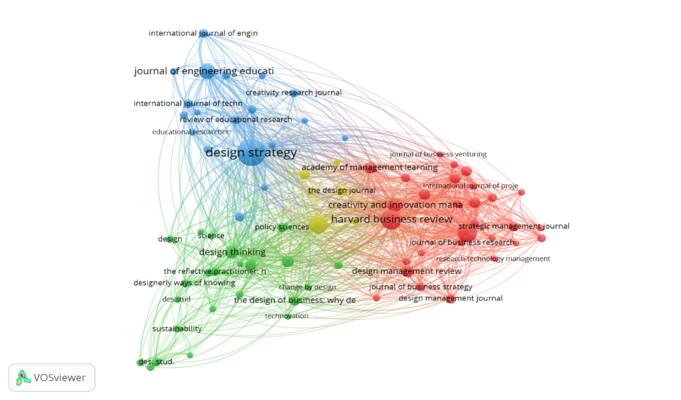

Figure 5. Network visualization map of co-citation analysis for journals on design thinking from 2000 to 2021.

The Most Used Author Keyword and Subject Area
The author's keywords help us determine the connections between a research field and others related to it. Furthermore, the frequency of keywords assists in identifying the attempt to highlight covered in this field's publications. A co-occurrence analysis was selected from the menu of the VOSviewer systems to generate a network map of the most frequently used author keywords based on bibliographic data.The main contents of the study are summarized through keywords. The keywords in an article can also provide helpful information, including goals, techniques, and perspectives (Tian et al., 2018). As a result, keyword frequency analysis is essential for analyzing hot topics and trends in the field (Z. Wang et al., 2018).

From 2000 to 2021, a co-occurrence analysis of author keywords was conducted. A minimum of 10 keyword occurrences was selected as a threshold for the study. Out of 3240 keywords, 59 were positively connected. There are five major clusters in the results (Figure 6). Each clusterreflects a subfield of design education research. A keyword resembling (redcluster) are "design", "design education", "production", and "technology" are related to the analytical aspects of design thinking, as seen in the green, yellow, blue, red, and purple clusters. Keywords suchas "innovation”, "creativity", "problem-based learning", and "collaboration" are emphasized in the green cluster, which focuseson the fundamental topic of design thinking education.Next, in the blue cluster are keywords like “design thinking”, “sustainability”, “conceptual”, “values”, and “co-creation” that are associated with the core of design thinking application.

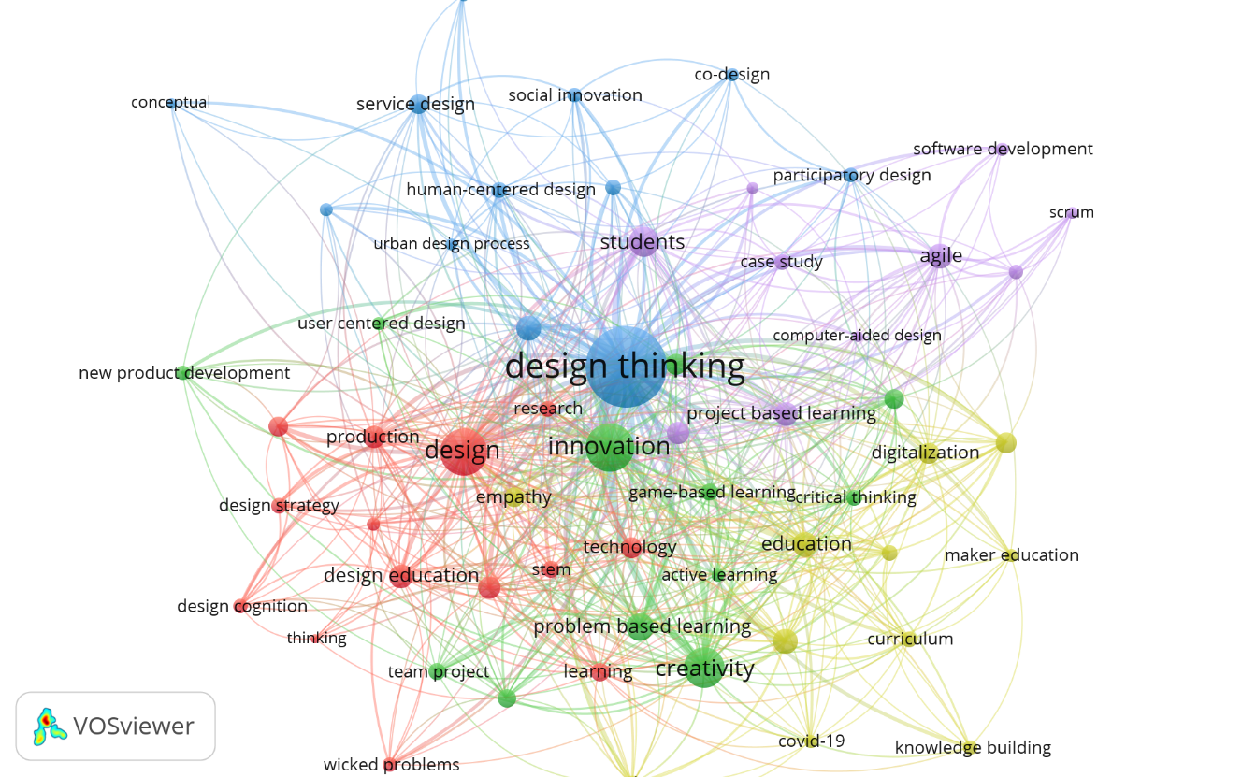
Figure 6. Co-occurrence network map of author keywords from articles published on design thinking from 2000 to 2021.

Based on the total link strength of the design thinking research publication, Table 7 shows the first 20 keywords. In articles with the highest total link strength, links, and occurrences, the author keyword "design thinking" has been the most frequently utilized(1294 total link strength: 1054 occurrences). "innovation" was the 2nd most common author keyword, with 390 occurrences. "design" and "creativity" are the following most popular author keywords, indicating that this is the most investigated and published aspect of design thinking. The frequency of the most often used author keywords in the articles reviewed in this study paints a picture of design thinking research.As a result, future research can be derived from the findings.

Table 7.Top 20 keywords of the design thinking research publication (rank based on total link strength).
Author Keywords | Total Link Strength | Occurrences | Links | Cluster
Design Thinking | 1294 | 1054 | 58 | 3
Innovation | 390 | 180 | 51 | 2
Design | 369 | 200 | 53 | 1
Creativity | 265 | 123 | 40 | 2
Students | 145 | 72 | 34 | 5
Problem-Based Learning | 116 | 49 | 28 | 2
Education | 95 | 40 | 30 | 4
Teaching | 92 | 45 | 25 | 4
Agile | 90 | 38 | 24 | 5
Sustainability | 87 | 41 | 29 | 3
Design Education | 81 | 42 | 25 | 1
Project-Based Learning | 77 | 33 | 26 | 5
Engineering | 73 | 38 | 25 | 1
Production | 69 | 33 | 28 | 1
Prototype | 67 | 25 | 28 | 5
Collaboration | 66 | 35 | 27 | 2
Digitalization | 61 | 28 | 22 | 4
Technology | 60 | 30 | 24 | 1
Entrepreneurship | 59 | 27 | 19 | 4
Empathy | 53 | 28 | 22 | 4

As highlighted in table 8, applying design thinking in such a broad framework has led to outputs that academics and communities have extensively recognized. This scenario contributes significantly to the field. Design thinking has been used mainlyin the computer science area, with 740 total publications, based on the number of co-occurrences of author keywords. It's also been widely used in avarietyof disciplines, including the social sciences (655 total publications), engineering (631 total publications), business management and accounting (392 total publications), mathematics (206 total publications), art and humanities(192 total publications), and economicsand finance (141 total publications).

Table 8. Subject Areaof the design thinking research publication.
Subject Area | Total Publications (TP) | Percentage (%)
Computer Science | 740 | 39.47%
Social Sciences | 655 | 34.93%
Engineering | 631 | 33.65%
Business, Management, and Accounting | 392 | 20.91%
Mathematics | 206 | 10.99%
Arts and Humanities | 192 | 10.24%
Economics, Econometrics, and Finance | 141 | 7.52%
Decision Sciences | 96 | 5.12%
Environmental Science | 84 | 4.48%
Medicine | 79 | 4.21%

Our findings, however, are not without limitations. This bibliometric study does have certain limits. First, the information presented is limited to the Scopus database, representing only a minor portion of the global production in this field. The scientific literature on design thinking is expected to be much more comprehensive. Second, the data in this study covered the period from 2000 to December 2021, and thelatest study is published daily. Third, if the authors had not mentioned our study inclusion descriptions in the publication names, we might have missed some design thinkingpapers. Fourth, the number of citations used to evaluate the research impact may not adequately reflect the value of each study.

- CONCLUSION

The findings of the bibliometric analysis show that design thinking is on trendworldwide. Leading to an improvement indesign learning and enhanced best pedagogical practices. Indirectly, it will impact the exploration of how these core design approaches might be implemented in corporate problem solving and innovation. Design thinking has emerged in various disciplines worldwide, whether in formal or informal educational contexts, due to the technological boom.

In this perspective, the publications in design thinking were thoroughly examined for their development trends, general characteristics, collaborative networks, and current hot spots. Since the basic concept of design thinking was introduced, the discipline has expanded rapidly. Many significant research results have arisen, particularly in recent years, with an increasing rate of publications. Although design thinking received little attention from the academic community in the first decade following its debut in 1954, the findings show that the idea of design thinking started to emerge as a significant trend in 2000 and expanded in 2014 until today.

Design thinking research is interdisciplinary mainly, encompassing a wide range of problems researched by scholars from various fields and perspectives. Along with a growth in the number of publications every year, this analysis shows that the average number of authors per document has increased significantly. Ultimately, these analyses can contribute to the forecast of future design thinking research and the evolution of design thinking.Furthermore, the outcomes of this study show that design thinking research is a rising trend that is still expanding and will continue to grow in the future.

ACKNOWLEDGEMENT
The authors reported no potential conflict of interest

REFERENCES
Aguado, G., FernÃ¡ndez, C., Garreta-Domingo, M., Griset, R., & Valls, A. (2014). Course sprints: Combining teacher training, design thinking and hackathons. In 1st International Conference on Learning and Collaboration Technologies, LCT 2014 - Held as Part of 16th International Conference on Human-Computer Interaction, HCI International 2014 (Vol. 8523, pp. 3–12). Springer Verlag. https://doi.org/10.1007/978-3-319-07482-5_1
Ahmi, A., Tapa, A., & Hamzah, A. H. (2020). Mapping of Financial Technology (FinTech) Research: A Bibliometric Analysis. International Journal of Advanced Science and Technology, 29(8), 379–392.
Aldalalah, O. M. A. A. (2022). Employment the word cloud in brainstorming via the web and its effectiveness in developing the design thinking skill. International Journal of Instruction, 15(1), 1045–1064. https://doi.org/10.29333/iji.2022.15159a
Androutsos, A., & Brinia, V. (2019). Developing and piloting a pedagogy for teaching innovation, collaboration, and co-creation in secondary education based on design thinking, digital transformation, and entrepreneurship. Education Sciences, 9(2). https://doi.org/10.3390/educsci9020113
Annesley, T. M. (2010). The title says it all. Clinical Chemistry, 56(3), 357–360. https://doi.org/10.1373/clinchem.2009.141523
Balakrishnan, B., Azman, M. N. A., Sharif, A. M., Yaacob, M. I. H., Zain, H. H. M., & Hock, K. E. (2021). The Effectiveness of a Design Thinking Tool for the Development of Creativity in Teaching STEM Subjects among Special Needs Education Teachers. International Journal of Science, Mathematics and Technology Learning, 28(1), 15–26. https://doi.org/10.18848/2327-7971/CGP/V28I01/15-26
Beckman, S. L., & Barry, M. (2007). Innovation as a learning process: Embedding design thinking. In California Management Review (Vol. 50, Issue 1, pp. 25–56). University of California Press. https://doi.org/10.2307/41166415
Beligatamulla, G., Rieger, J., Franz, J., & Strickfaden, M. (2019). Making Pedagogic Sense of Design Thinking in the Higher Education Context. Open Education Studies, 1(1), 91–105. https://doi.org/10.1515/edu-2019-0006
Benita, F., Virupaksha, D., Wilhelm, E., & Tunçer, B. (2021). A smart learning ecosystem design for delivering Data-driven Thinking in STEM education. Smart Learning Environments, 8(1). https://doi.org/10.1186/s40561-021-00153-y
Bhandari, A. (2022). Design Thinking: from Bibliometric Analysis to Content Analysis, Current Research Trends, and Future Research Directions. In Journal of the Knowledge Economy (Issue 0123456789). Springer US. https://doi.org/10.1007/s13132-022-00920-3
Bharathi, S. V., & Pande, M. (2019). Why design thinking in IT business management program? An exploratory study on students’ design thinking learning experience. International Journal of Information and Communication Technology Education, 15(4), 76–93. https://doi.org/10.4018/IJICTE.2019100106
Boillat, T., Tuffnell, C., Rivas, H., Aloul, F., & Montana, C. (2020). Design4Health bootcamp: A design thinking approach to improve the 21stcentury skills of health, engineering and design students. In 2020 Advances in Science and Engineering Technology International Conferences, ASET 2020. Institute of Electrical and Electronics Engineers Inc. https://doi.org/10.1109/ASET48392.2020.9118202
BostrÃ¶m, J., Hillborg, H., & Lilja, J. (2021). Cultural dynamics and tensions when applying design thinking for improving health-care quality. International Journal of Quality and Service Sciences, 13(1), 16–28. https://doi.org/10.1108/IJQSS-04-2019-0055
Brown, T. (2008). Design thinking. Harvard Business Review, 86(6), 84–92. https://www.scopus.com/inward/record.uri?eid=2-s2.0-46749127039&partnerID=40&md5=1037ea2f49975106b2f4aa365f82c124
Brown, Tim. (2019). Business Concepts for Fundraising Change By Design : How Design Thinking Inspires Innovation Business Concepts for Fundraising. Mwo, 124.
Buchstab, V. Von. (2005). Automotive design: Thinking outside the box. In Design Engineering (Toronto) (Vol. 51, Issue 8, pp. 14–16). https://www.scopus.com/inward/record.uri?eid=2-s2.0-30144436120&partnerID=40&md5=681451afb9496db4924c2e364d1788e4
Chen, T.-K., Chowanda, A., Udjaja, Y., & Fang, H.-L. (2019). Design Thinking for Computational Creativity - A Case Study of International Exchanges Using Game and Animation (2014-Recent). In 2019 IEEE International Conference on Engineering, Technology and Education, TALE 2019. Institute of Electrical and Electronics Engineers Inc. https://doi.org/10.1109/TALE48000.2019.9225911
Chiu, T. K. F., Chai, C. S., Williams, P. J., & Lin, T.-J. (2021). Teacher Professional Development on Self-Determination Theoryâ€“Based Design Thinking in STEM Education. Educational Technology and Society, 24(4), 153–165. https://www.scopus.com/inward/record.uri?eid=2-s2.0-85117966884&partnerID=40&md5=ead582100c5a26154ccb2c92fcc40d75
Dorst, K. (2011). The core of ‘design thinking’ and its application. Design Studies, 32(6), 521–532. https://doi.org/10.1016/j.destud.2011.07.006
Dunne, D., & Martin, R. (2006). Design thinking and how it will change management education: An interview and discussion. In Academy of Management Learning and Education (Vol. 5, Issue 4, pp. 512–523). George Washington University. https://doi.org/10.5465/AMLE.2006.23473212
Fisher, W. P., Oon, E. P.-T., & Benson, S. (2018). Applying Design Thinking to systemic problems in educational assessment information management. In 2017 Joint IMEKO TC1-TC7-TC13 Symposium: Measurement Science Challenges in Natural and Social Sciences (Vol. 1044, Issue 1). Institute of Physics Publishing. https://doi.org/10.1088/1742-6596/1044/1/012012
Gleason, B., & Cherrez, N. J. (2021). Design Thinking Approach to Global Collaboration and Empowered Learning: Virtual Exchange as Innovation in a Teacher Education Course. TechTrends, 65(3), 348–358. https://doi.org/10.1007/s11528-020-00573-6
Goi, H. C., & Tan, W.-L. (2021). Design Thinking as a Means of Citizen Science for Social Innovation. Frontiers in Sociology, 6. https://doi.org/10.3389/fsoc.2021.629808
Guaman-Quintanilla, S., Everaert, P., Chiluiza, K., & Valcke, M. (2022). Impact of design thinking in higher education: a multi-actor perspective on problem solving and creativity. International Journal of Technology and Design Education, 0123456789. https://doi.org/10.1007/s10798-021-09724-z
Harun, A. F., Ismail, J., Shiang, H. Y., Noor, N. L. M., Baharin, H., & Suliman, S. I. (2019). An exploratory study in conceptualizing user view on digital taste using design thinking. Indonesian Journal of Electrical Engineering and Computer Science, 17(1), 379–388. https://doi.org/10.11591/ijeecs.v17.i1.pp379-388
He, J., & Ortiz, J. (2021). Sustainable business modeling: The need for innovative design thinking. Journal of Cleaner Production, 298. https://doi.org/10.1016/j.jclepro.2021.126751
Henriksen, D., Richardson, C., & Mehta, R. (2017). Design thinking: A creative approach to educational problems of practice. Thinking Skills and Creativity, 26, 140–153. https://doi.org/10.1016/j.tsc.2017.10.001
Johann, D. A., Nunes, A. de F. P., Santos, G. B. dos, Silva, D. J. C. da, Bresciani, S. A. T., & Lopes, L. F. D. (2020). Mapping of scientific production on design thinking as a tool for entrepreneurship education: a bibliometric study of a decade. World Journal of Entrepreneurship, Management and Sustainable Development, 16(4), 271–285. https://doi.org/10.1108/WJEMSD-05-2019-0028
Johansson-SkÃ¶ldberg, U., Woodilla, J., & Ã‡etinkaya, M. (2013). Design thinking: Past, present and possible futures. Creativity and Innovation Management, 22(2), 121–146. https://doi.org/10.1111/caim.12023
Johansson-Sköldberg, U., Woodilla, J., & Çetinkaya, M. (2013). Design thinking: Past, present and possible futures. Creativity and Innovation Management, 22(2), 121–146. https://doi.org/10.1111/caim.12023
Kaivo-Oja, J. (2014). New service design thinking in the ubiquitous media: New ideas for journalism that help and serve people. Touchpoint, 5(3), 34–39. https://www.scopus.com/inward/record.uri?eid=2-s2.0-84894467540&partnerID=40&md5=c27ff3a964bcd23ac0410b88a1a51ef6
Liu, Z. (2020). The Construction of Environmental Art Design Thinking Based on Hand Drawing and Computer Drawing. In 1st International Conference on Computer Applied Science and Information Technology, ICCASIT 2020 (Vol. 1574, Issue 1). Institute of Physics Publishing. https://doi.org/10.1088/1742-6596/1574/1/012114
Lorusso, L., Lee, J. H., & Worden, E. A. (2021). Design Thinking for Healthcare: Transliterating the Creative Problem-Solving Method Into Architectural Practice. Health Environments Research and Design Journal, 14(2), 16–29. https://doi.org/10.1177/1937586721994228
Loyola, C. C., Grimberg, C. A., & Colomer, Ã. B. (2020). Early childhood teachers making multiliterate learning environments: The emergence of a spatial design thinking process. Thinking Skills and Creativity, 36. https://doi.org/10.1016/j.tsc.2020.100655
Lyche, W., Berg, A., & Andreassen, K. (2018). Parametric design thinking about digital and material surface patterns. In 20th International Conference on Engineering and Product Design Education, E and PDE 2018. Institution of Engineering Designers, The Design Society. https://www.scopus.com/inward/record.uri?eid=2-s2.0-85057770011&partnerID=40&md5=66951f34d5eeee5868561eae74a7ce0b
Meinel, C., & Leifer, L. (2012). Design thinking research. In Design Thinking Research: Measuring Performance in Context (pp. 1–10). Springer Berlin Heidelberg. https://doi.org/10.1007/978-3-642-31991-4_1
Menezes, J. H. D. O. (2019). From tinkering methods to design thinking: Primordial thoughts in design research. In 22nd International Conference on Engineering Design, ICED 2019 (Vol. 2019, pp. 3911–3917). Cambridge University Press. https://doi.org/10.1017/dsi.2019.398
Mongeon, P., & Paul-Hus, A. (2016). The journal coverage of Web of Science and Scopus: a comparative analysis. Scientometrics, 106(1), 213–228. https://doi.org/10.1007/s11192-015-1765-5
O’Callaghan, G., & Connolly, C. (2020). Developing creativity in computer science initial teacher education through design thinking. In 2020 Conference on United Kingdom and Ireland Computing Education Research, UKICER 2020 (pp. 45–50). Association for Computing Machinery. https://doi.org/10.1145/3416465.3416469
OCDE. (2018). The Future of Education and Skills: Education 2030. OECD Education Working Papers, 23. http://www.oecd.org/education/2030/E2030 Position Paper (05.04.2018).pdf
Palacin-Silva, M., Khakurel, J., Happonen, A., Hynninen, T., & Porras, J. (2017). Infusing Design Thinking into a Software Engineering Capstone Course. In 30th IEEE Conference on Software Engineering Education and Training, CSEE and T 2017 (Vol. 2017, pp. 212–221). Institute of Electrical and Electronics Engineers Inc. https://doi.org/10.1109/CSEET.2017.41
Parmar, A. J. (2015). Bridging gaps in engineering education: Design thinking a critical factor for project based learning. In 44th Annual Frontiers in Education Conference, FIE 2014 (Vol. 2015). Institute of Electrical and Electronics Engineers Inc. https://doi.org/10.1109/FIE.2014.7044081
Pellegrini, M. (2020). The intersection of design thinking and website creation: Findings from two case studies. In 38th ACM International Conference on Design of Communication, SIGDOC 2020. Association for Computing Machinery, Inc. https://doi.org/10.1145/3380851.3416750
Pirri, S., Lorenzoni, V., & Turchetti, G. (2020). Scoping review and bibliometric analysis of Big Data applications for Medication adherence: An explorative methodological study to enhance consistency in literature. BMC Health Services Research, 20(1), 1–23. https://doi.org/10.1186/s12913-020-05544-4
Pruneau, D., Freiman, V., LÃ©ger, M. T., Dionne, L., Richard, V., & Laroche, A.-M. (2021). Design Thinking and Collaborative Digital Platforms: Innovative Tools for Co-creating Sustainability Solutions. In World Sustainability Series (pp. 207–226). Springer Science and Business Media Deutschland GmbH. https://doi.org/10.1007/978-3-030-78825-4_13
Purdy, J. P. (2014). What can design thinking offer writing studies? College Composition and Communication, 65(4), 612–641. https://www.scopus.com/inward/record.uri?eid=2-s2.0-84901722129&partnerID=40&md5=78b57404a37aca5fd1895a4750c2daa9
Qi, S., Hua, F., Xu, S., Zhou, Z., & Liu, F. (2021). Trends of global health literacy research (1995-2020): Analysis of mapping knowledge domains based on citation data mining. PLoS ONE, 16(8 August). https://doi.org/10.1371/JOURNAL.PONE.0254988
Qian, M., Zhao, B., & Gao, Y. (2019). Exploring the Training Path of Design Thinking of Students in Educational Technology. In 2019 IEEE International Conference on Computer Science and Educational Informatization, CSEI 2019 (pp. 315–319). Institute of Electrical and Electronics Engineers Inc. https://doi.org/10.1109/CSEI47661.2019.8938895
Razzouk, R., & Shute, V. (2012). What Is Design Thinking and Why Is It Important? Review of Educational Research, 82(3), 330–348. https://doi.org/10.3102/0034654312457429
Reinecke, S. (2016). What is it that design thinking and marketing management can learn from each other? In Design Thinking for Innovation: Research and Practice (pp. 151–162). Springer International Publishing. https://doi.org/10.1007/978-3-319-26100-3_11
Scott, J. A., Bouzos, E., Hendricks, M. P., & Asuri, P. (2021). Cultivating Student Adoption of Design Thinking and Entrepreneurial Skills by Addressing Complex Challenges in Healthcare Through Industry Partnerships. In 2021 ASEE Virtual Annual Conference, ASEE 2021. American Society for Engineering Education. https://www.scopus.com/inward/record.uri?eid=2-s2.0-85124527217&partnerID=40&md5=b66c32275b2b88b868072fcaa88c29bf
Soledad Ramírez-Montoya, M., Castillo-Martínez, I. M., Sanabria-Z, J., & Miranda, J. (2022). Complex Thinking in the Framework of Education 4.0 and Open Innovation-A Systematic Literature Review. Journal of Open Innovation: Technology, Market, and Complexity Article. https://doi.org/10.3390/joitmc8010004
Souza, A., Ferreira, B., Valentim, N., Correa, L., Marczak, S., & Conte, T. (2020). Supporting the teaching of design thinking techniques for requirements elicitation through a recommendation tool. IET Software, 14(6), 693–701. https://doi.org/10.1049/iet-sen.2019.0300
Taajamaa, V., Kirjavainen, S., Repokari, L., Sjoman, H., Utriainen, T., & Salakoski, T. (2014). Dancing with ambiguity design thinking in interdisciplinary engineering education. In 2013 IEEE-Tsinghua International Design Management Symposium, TIDMS 2013 (pp. 353–360). Institute of Electrical and Electronics Engineers Inc. https://doi.org/10.1109/TIDMS.2013.6981258
Tian, X., Geng, Y., Sarkis, J., & Zhong, S. (2018). Trends and features of embodied flows associated with international trade based on bibliometric analysis. Resources, Conservation and Recycling, 131(September 2017), 148–157. https://doi.org/10.1016/j.resconrec.2018.01.002
Viswanathan, V. K., & Linsey, J. S. (2012). Physical models and design thinking: A study of functionality, novelty and variety of ideas. Journal of Mechanical Design, Transactions of the ASME, 134(9). https://doi.org/10.1115/1.4007148
Wallis, S. E. (2019). Understanding the Systemic Structure of Models: A Missing Piece of the Design Thinking Puzzle. In She Ji (Vol. 5, Issue 4, pp. 390–394). Tongji University Press. https://doi.org/10.1016/j.sheji.2019.11.014
Wang, X., & Zhang, Y. (2020). The Application of Art Design Thinking in Visual Works from the Perspective of Digital Media. In 2020 3rd International Conference on Computer Information Science and Application Technology, CISAT 2020 (Vol. 1634, Issue 1). IOP Publishing Ltd. https://doi.org/10.1088/1742-6596/1634/1/012006
Wang, Z., Zhao, Y., & Wang, B. (2018). A bibliometric analysis of climate change adaptation based on massive research literature data. Journal of Cleaner Production, 199, 1072–1082. https://doi.org/10.1016/j.jclepro.2018.06.183
Yen, W.-H., Chang, C.-C., & Willliams, J. (2021). Gender Differences in Engineering Design Thinking in a Project-Based STEAM Course. In 4th International Conference on Innovative Technologies and Learning, ICITL 2021 (Vol. 13117, pp. 557–566). Springer Science and Business Media Deutschland GmbH. https://doi.org/10.1007/978-3-030-91540-7_57
Zakaria, R., Ahmi, A., Ahmad, A. H., & Othman, Z. (2021). Worldwide melatonin research: a bibliometric analysis of the published literature between 2015 and 2019. Chronobiology International, 38(1), 27–37. https://doi.org/10.1080/07420528.2020.1838534
Zakaria, R., Ahmi, A., Ahmad, A. H., Othman, Z., Azman, K. F., Ab Aziz, C. B., Ismail, C. A. N., & Shafin, N. (2021). Visualising and mapping a decade of literature on honey research: a bibliometric analysis from 2011 to 2020. Journal of Apicultural Research, 60(3), 359–368. https://doi.org/10.1080/00218839.2021.1898789

